Project Design Phase-II
Data Flow Diagram & User Stories

Date | 5 February 2026
Team ID | LTVIP2026TMIDS61992
Project Name | visualization tool for electric vehicle charge and range analysis
Maximum Marks | 4 Marks

Data Flow Diagrams:
A Data Flow Diagram (DFD) is a traditional visual representation of the information flows within a system. A neat and clear DFD can depict the right amount of the system requirement graphically. It shows how data enters and leaves the system, what changes the information, and where data is stored.

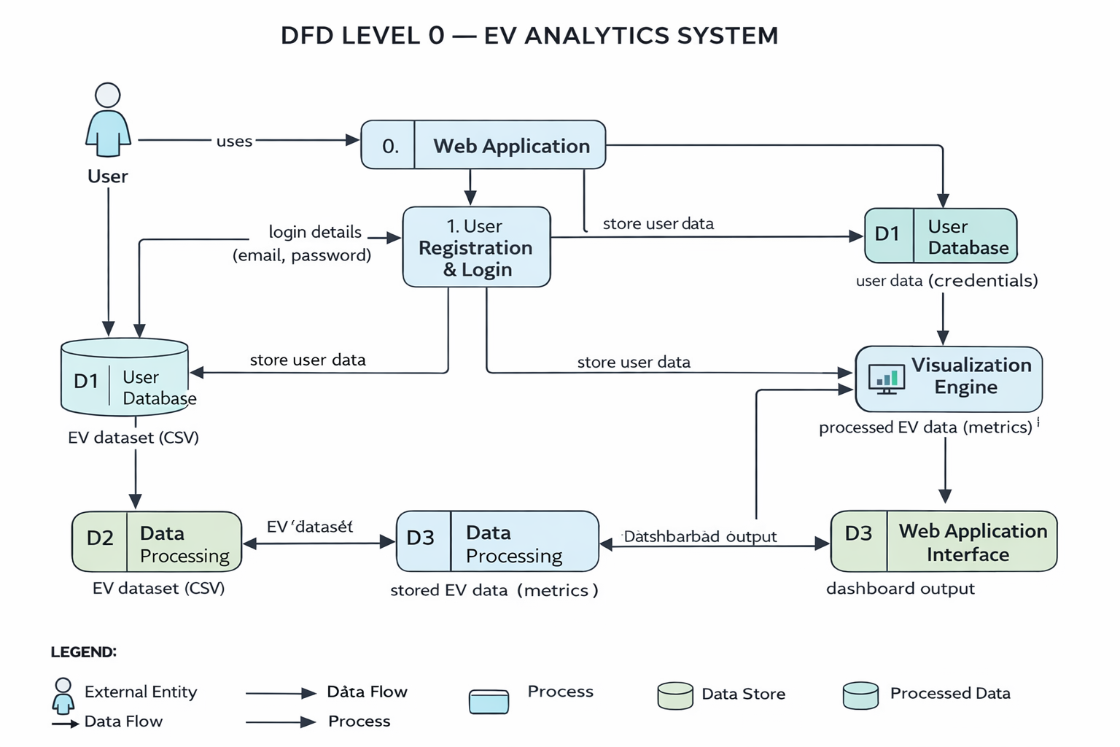

User Stories:

User Type | Functional Requirement (Epic) | User Story Number | User Story / Task | Acceptance Criteria | Priority | Release
Customer (Web User) | Registration | USN-1 | As a user, I can register using email and password. | User account created successfully | High | Sprint-1
Customer (Web User) | Registration | USN-2 | As a user, I receive confirmation after registration. | Confirmation message displayed | High | Sprint-1
Customer (Web User) | Login | USN-3 | As a user, I can log in using email and password. | User redirected to dashboard | High | Sprint-1
Customer (Web User) | Dashboard Access | USN-4 | As a user, I can access the EV analytics dashboard. | Dashboard loads successfully | High | Sprint-2
Customer (Web User) | KPI View | USN-5 | As a user, I can see average range and price KPIs. | KPIs displayed correctly | High | Sprint-2
Customer (Web User) | Data Visualization | USN-6 | As a user, I can view EV charts and comparisons. | Charts load without errors | High | Sprint-2
Customer (Web User) | Story View | USN-7 | As a user, I can view the EV analytics story. | Story opens in web page | Medium | Sprint-3
Customer (Web User) | Contact | USN-8 | As a user, I can send a message through contact form. | Success notification shown | Medium | Sprint-4
Administrator | Data Management | USN-9 | As an admin, I can update the EV dataset. | Updated data reflects in dashboard | Medium | Sprint-3

